On May 15, 2019, 12:50 p.m. myself and John visited Advance Auto Parts and determined that there was no illicit storm drain discharge.

Greg Durgin

Code Compliance Officer

Town of Lake Park

O 561 881.3321

C 561 718.1032

**From:** John Wylie <[jwylie@lakeparkflorida.gov](mailto:jwylie@lakeparkflorida.gov)>   
**Sent:** Tuesday, May 14, 2019 2:06 PM  
**To:** Greg Durgin <[Gdurgin@lakeparkflorida.gov](mailto:Gdurgin@lakeparkflorida.gov)>  
**Cc:** Richard Scherle <[rscherle@lakeparkflorida.gov](mailto:rscherle@lakeparkflorida.gov)>; Howard Butts <[hbutts@lakeparkflorida.gov](mailto:hbutts@lakeparkflorida.gov)>; Dwayne Bell <[dbell@lakeparkflorida.gov](mailto:dbell@lakeparkflorida.gov)>  
**Subject:** FW: Possible Illicit Discharge Advanced Auto Parts store  
**Importance:** High

Hi Greg,

Referencing our phone conversation this is the illicit discharge item we discussed, please copy me on all information collected, actions taken and the resolution achieved. This issue is a high priority item and will be added to the towns annual storm water report  – if you require assistance please let me know.

**John Wylie**

Town of Lake Park

Storm Water

650 Old Dixie Highway

Lake Park, Florida 33403

[jwylie@lakeparkflorida.gov](mailto:jwylie@lakeparkflorida.gov)

Office 561-881-3345

Mobile 561-718-1026

**From:** Richard Scherle   
**Sent:** Tuesday, May 14, 2019 12:16 PM  
**To:** John Wylie  
**Cc:** Howard Butts  
**Subject:** RE: Possible Illicit Discharge Advanced Auto Parts store

Please get code involved.  Thank you.

**From:** John Wylie   
**Sent:** Tuesday, May 14, 2019 11:34 AM  
**To:** Richard Scherle <[rscherle@lakeparkflorida.gov](mailto:rscherle@lakeparkflorida.gov)>  
**Cc:** Howard Butts <[hbutts@lakeparkflorida.gov](mailto:hbutts@lakeparkflorida.gov)>  
**Subject:** Possible Illicit Discharge Advanced Auto Parts store

Richard,

There appears to be an illicit discharge at the rear of Advanced Auto Parts store, this is on an internal storm drain located in their parking lot. It appears that someone has changed their vehicle oil at the storm drain and left an oil filter next to the storm drain grate. I have not entered their property to confirm this, I felt a code officer should be present. This storm drain would be considered private and not the property of the town. I am attaching a photo. Please advise on how you would like to proceed.

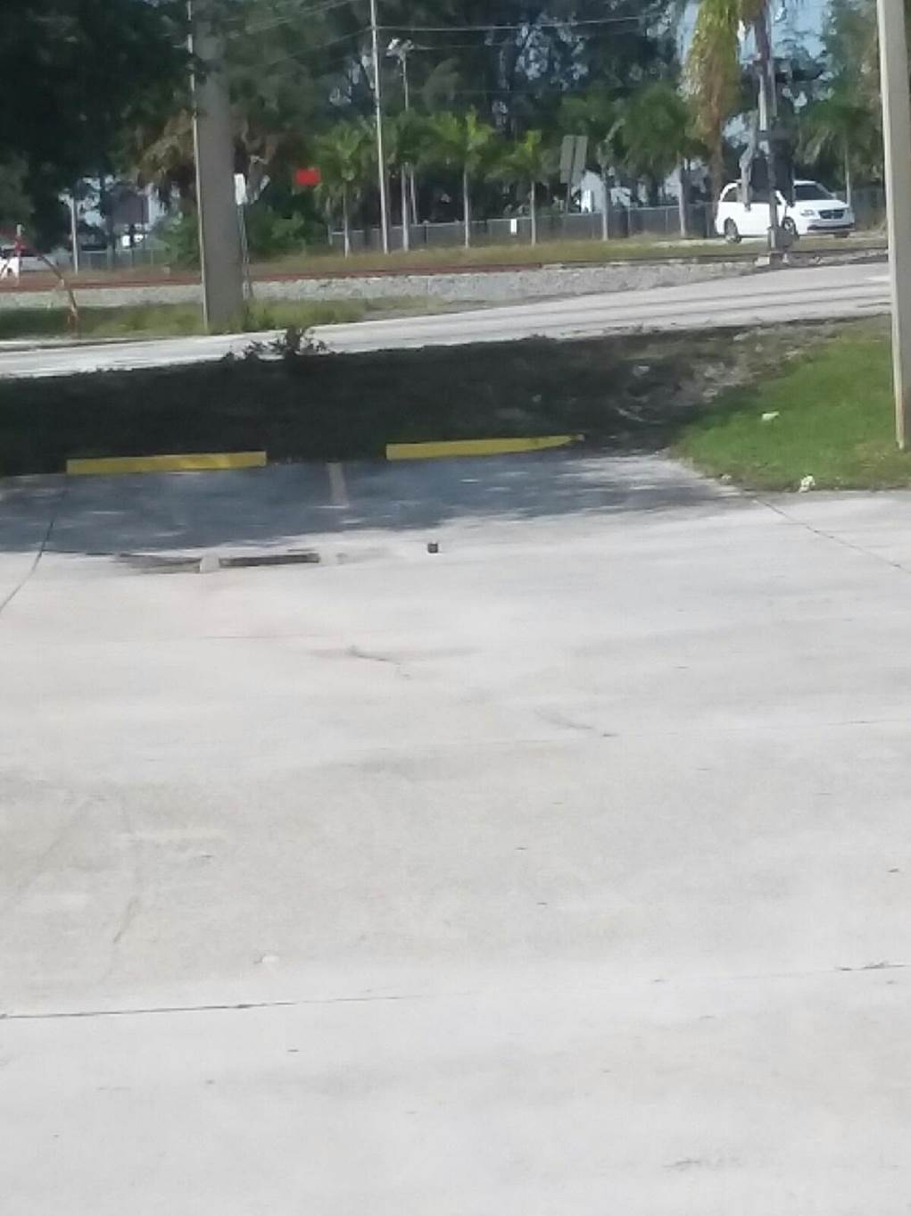

**John Wylie**

Town of Lake Park

Storm Water

650 Old Dixie Highway

Lake Park, Florida 33403

[jwylie@lakeparkflorida.gov](mailto:jwylie@lakeparkflorida.gov)

Office 561-881-3345

Mobile 561-718-1026